GSK Server Patching Process Runbook

**Document information**

|  |  |
| --- | --- |
| Create Date | July 2021 |
| Submitted By | Sagar saxena |
| Reviewed By |  |
| Document Name | GSK Server patching process RUNBOOK |
| Version number | 1.0 |

*The data contained in this document shall not be disclosed and shall not be duplicated, used, or disclosed in whole or in part for any purpose. If a contract is awarded to chosen parties as a result of or in connection with the submission of this data, the client or prospective client shall have the right to duplicate, use, or disclose this data to the extent provided in the contract. This restriction does not limit the client’s or prospective client’s right to use the information contained in the data if it is obtained from another source without restriction. The data subject to this restriction is contained in all marked sheets.*

***Version Control***

*All information given under this version overrides all and any kind of offers, assumptions, deliverables, and contracts given under any previous version. All previous versions of the subject Proposal stand null and void.*

**Document History**

|  |  |  |  |
| --- | --- | --- | --- |
| **Version** | **Date** | **Author / Reviewer** | **Change Description** |
| 1.0 | JULY 2021 | Sagar Saxena | * Draft based on Knowledge Absorption |
| 1.1 | Feb 2022 | Radhakrishnan Ramasamy | * Updated the table of contents and whole document with briefed process along with screeshots |

**table OF contents**

1. Release Portal Overview 4

1.1. Updating Release Road map 5

1.2. Create Containter 6

1.3. Pre-CAB Meeting 11

1.4. Create Change Request 12

1.5. Publish Change Details in Email 15

1.6. Publish server patching communication on Workplace groups 16

1.7. Configure Notification Email to Business Owners 17

1.8. Download Scope of Servers 17

2. SCCM Console Overview 18

2.1. Create Collection for Scope 18

2.1.1. Remove Old collection 20

2.2. Monitor ADR and SUG 21

2.3. Manage Software Updates 23

2.4. Enable Deployment 24

2.5. Review Released Software Updates and notifiy in email 24

2.6. SCCM Agent Remediation 24

3. Monitoring Patch Deployment 25

4. Create Final Summary Report ………………………………………………………………………………………………… 30

5. GSK Key Contacts & Roles 31

6. RACI Matrix 31

1. **Release Portal Overview**

Release Portal is used to Patch the servers which manage by business owners to control the Maintenance Windows for their owned servers. Patching/Application deployment will not be from SCCM if servers not onboarded in Release Portal.

[Home Page - Server release portal (gsk.com)](https://releaseportal.gsk.com/)

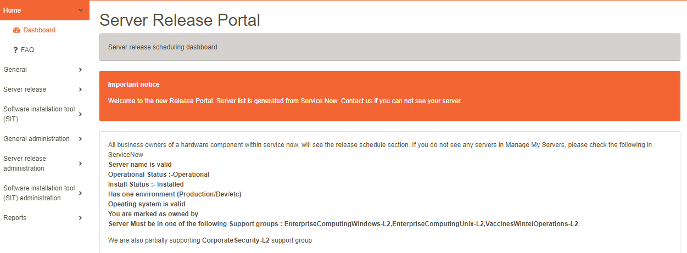

**1.1. Updating Release Road map**

Update Release Roadmap on Release portal [Page Sections - Server release portal (gsk.com)](https://releaseportal.gsk.com/Manage/PageSections)

* Go to [Page Sections - Server release portal (gsk.com)](https://releaseportal.gsk.com/Manage/PageSections)
* On left Pane click on manage Page sections under General Administration
* Update homepage Release Road map and save it.

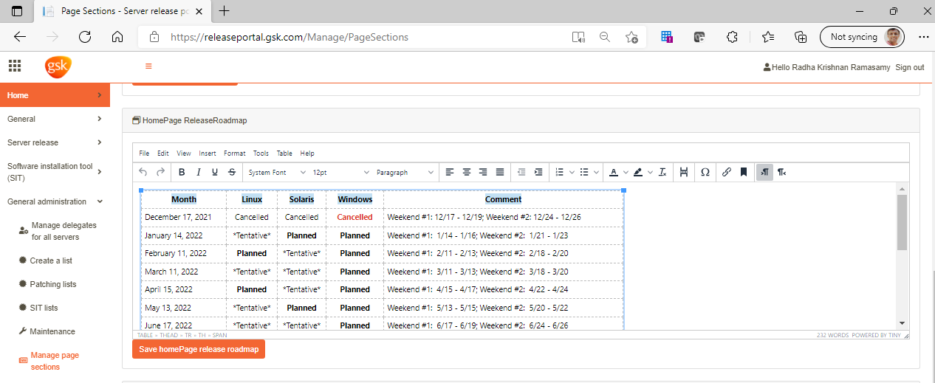

1.2. Create Containter

Create a container in service Now Group via release portal.

* Browse to <https://releaseportal.gsk.com/>
* On left pane go to “Create a List” under General Administration Manage

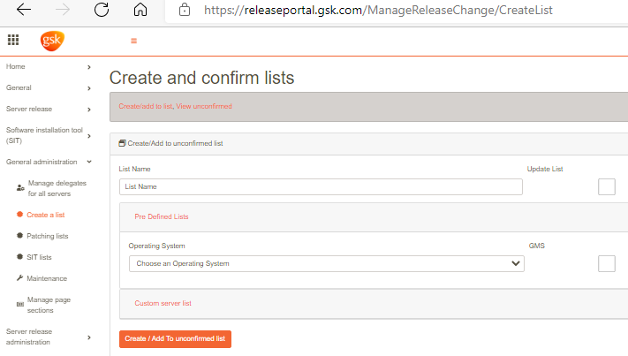

* Create the list of servers for container: Enter list name and select Operating system as Windows and click create/Add to unconfirmed list.

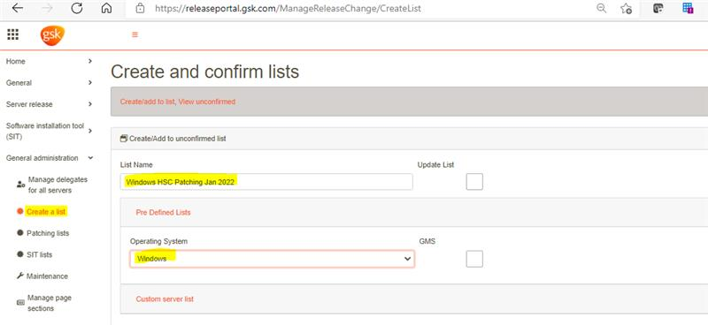

* Scroll down and locate your newly created list name under unconfirmed release list and click on view/Delete/Confirm details.

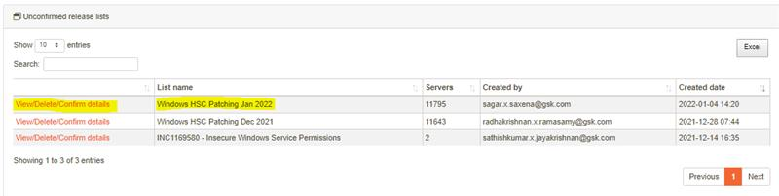

* If no changes need to be made on release list click on confirm Patching list (used for patching).

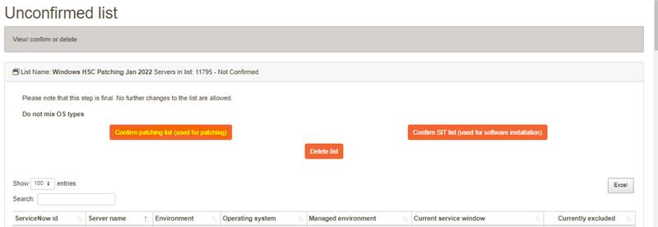

* In Patching Lists, change request find your list name under Confirm release lists and click on view details.

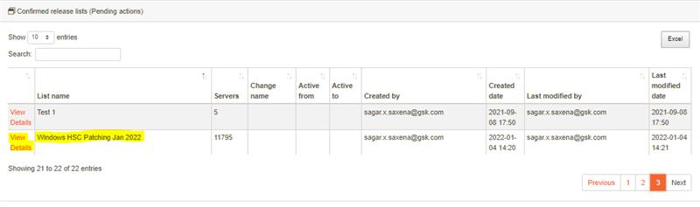

* Enter the container name as per naming convention under Servicenow Service Name box and hit Save And Confirm ServiceNow List Updated and wait for 20-30 minutes so that objects get populated in container successfully.

Container naming convention example: iths_server_release_windows_hsc_patching_and_updates_Jan_2022

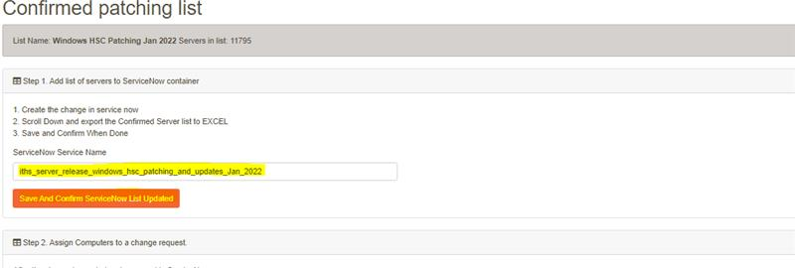

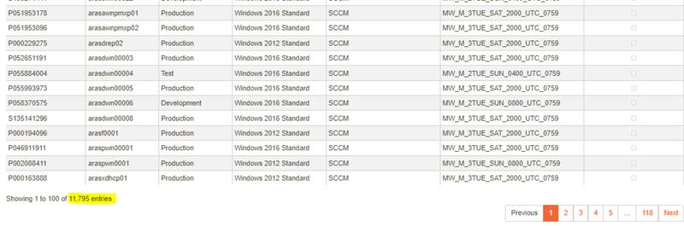

* We can verify the container creation and object populating process in service now in Ci

relationships. To open Ci relationship type “cmdb_rel_ci.list” in Filter navigator in service now top left.

* Search your container name in Parent box, you can verify the total number of objects added on top right side.

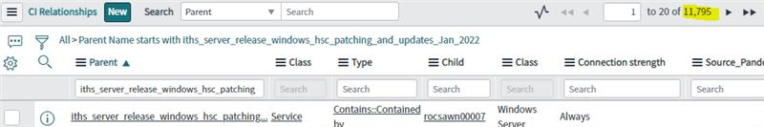

* Once Container get populated go back to Manage change requests and check on your list name under confirmed release list and wait for 30 seconds, it will auto- populate the container name in ServiceNow Service Name that we provided earlier.

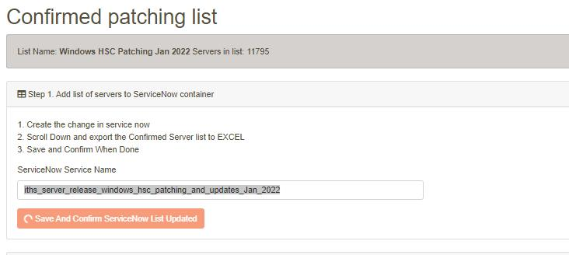

Note:- If you get any error while creating and populating container contact Kevin ([kevin.x.farrugia@gsk.com](mailto:kevin.x.farrugia@gsk.com))

* 1. Pre-CAB Meeting

Once Implementation Plan’s release component for monthly release get finalized after CAB meeting, Proceed for creating Change Request

* 1. Create Change Request

Create Change Request.  
Reference: CHG0080949

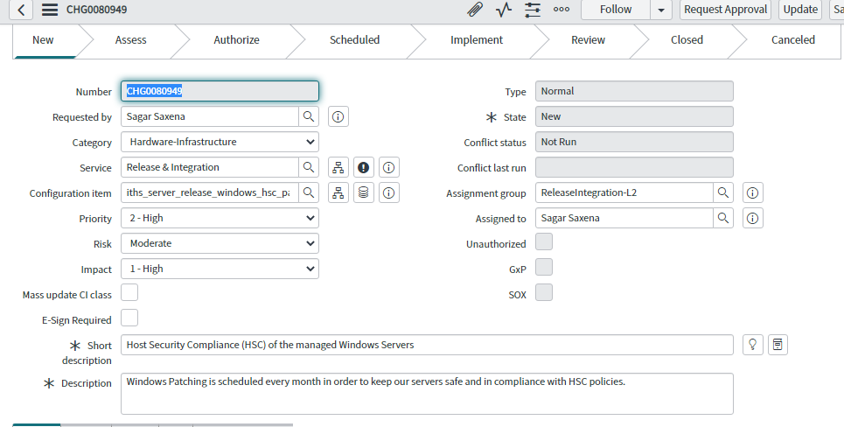

* Risk Assessment must perform for the change
* create outage (Business reason: Effected Server list is attached to this change. It will impact Wmservice, BIO,BIOSIP and all tech managed servers

Impacted Services:

* Make sure below three groups part of Change

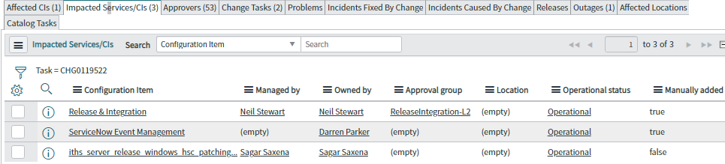

* Add this change to CAB review call (Every Tuesday)
* While creating change attach the below doc in change:



* Get approval from below group stack holders like below order

[AP-Global-Change-Management](https://servicenow.gsk.com/sys_user_group.do?sys_id=98f7cc801b339c101757773e0d4bcb18) -> AP-TA-EnterpriseComputingWindows-L2 ->  [ReleaseIntegration-L2](https://servicenow.gsk.com/sys_user_group.do?sys_id=2204b0651bf294d01757773e0d4bcbfb) ->[AP-CAB-ReleaseIntegration-L2](https://servicenow.gsk.com/sys_user_group.do?sys_id=74ce74c81bfb5c10b695539d5e4bcb25)

* Make sure change moved to scheduled/implemented state in expected start time

If there is any issue on Change related, reach to Rizwan from Change management Team immediately

* As soon as change is created update the change details in Release portal.  
  Release Portal🡪 Patching lists🡪 Select list name under confirmed release list.

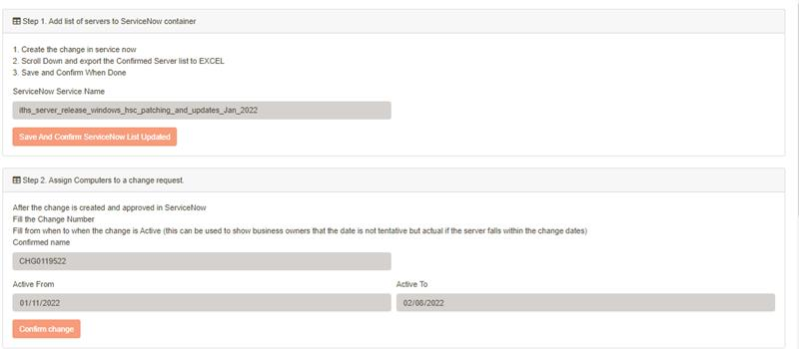

1.5. Publish Change Details in Email

Once change is created share change details to server release team, windows ops Team over email.

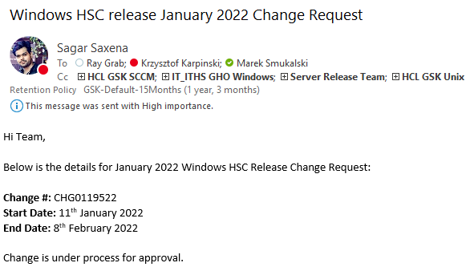

* 1. Publish server patching communication on Workplace groups

Publish server patching communication on Workplace groups: Tech Operations and Tech service outages. Link for Workplace groups: Tech Service Outages ([(20+) Tech Service Outages | Group | Workplace](https://gsk-workplace.workplace.com/groups/240967013283606)), Tech Operations ([(20+) Tech Operations | Group | Workplace](https://gsk-workplace.workplace.com/groups/116457975895853))

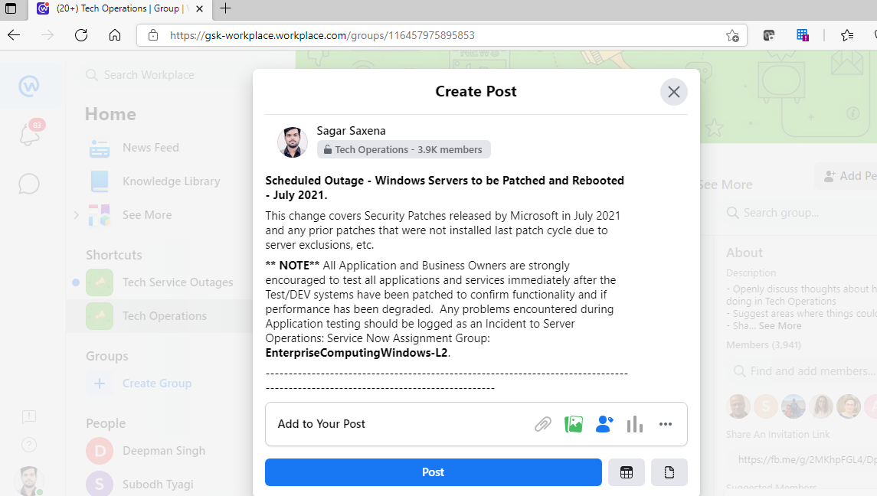

* 1. **Configure Notification Email to Business Owners**

After Updating Change details in Release portal send email to business owners vis release portal by including workplace link.

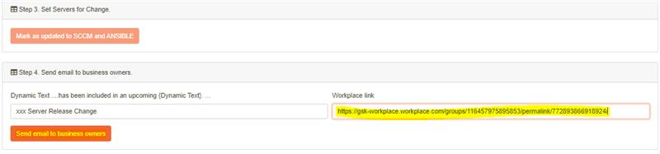

Wait for 60mins **DON”T CLOSE THE PAGE** meanwhile communication email sending to all Business Owners

After sending email to Business owners from release portal verification need to be done with Neil Stewart , Kevin or Ray if they did received the email or not.

* 1. Download Scope of Servers

Download server details included in monthly release from release portal in order to create collection for those servers.  
Release Portal 🡪 Patching lists🡪 select list name from confirmed release list 🡪 Click on Excel.

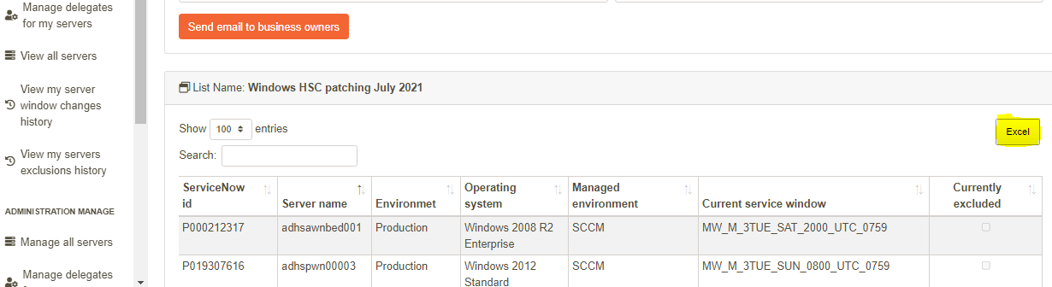

1. SCCM Console Overview

2.1. Create Collection for Scope

* Create collection on SCCM under Server Release Device collection🡪HSC Release🡪 2021 as per naming convention. (yyyymm - Change# - Windows Servers in Change) with limiting collection to All Tech Managed Servers.

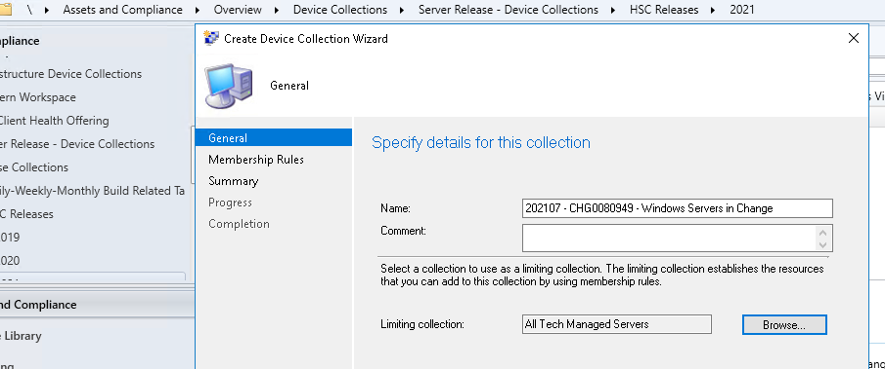

* Once collection is created add server objects in collection via right click tool.  
    
  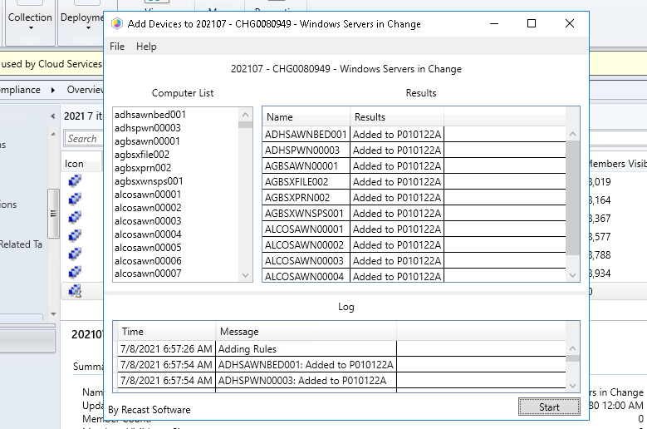

2.1.1 Remove Old collection

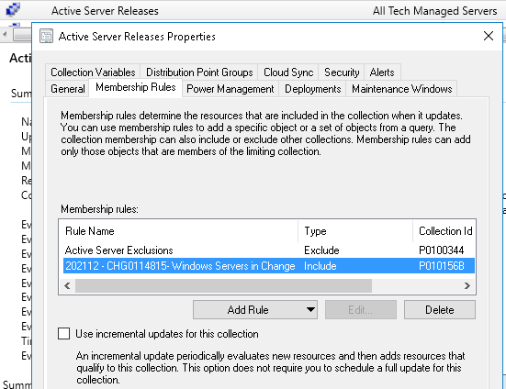

2.2. Monitor ADR and SUG

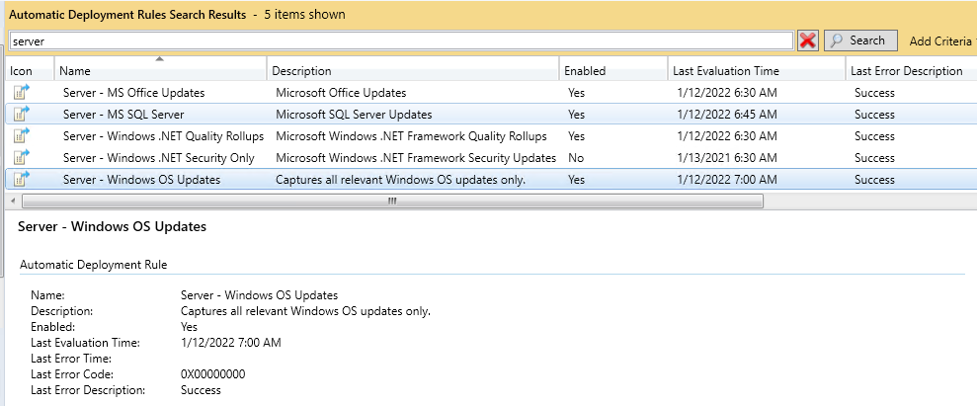

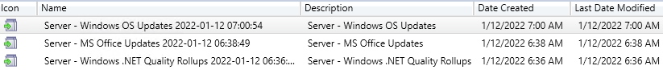



Note: If any issues occur during ADR evaluation need to monitor the logs and take action accordingly. Once completed , we need to verify and **rename the SUG as like below**

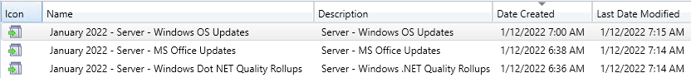

2.3. Manage Software Updates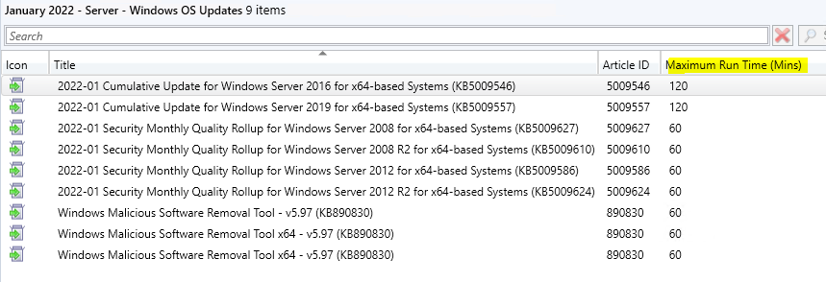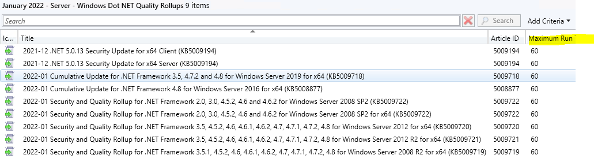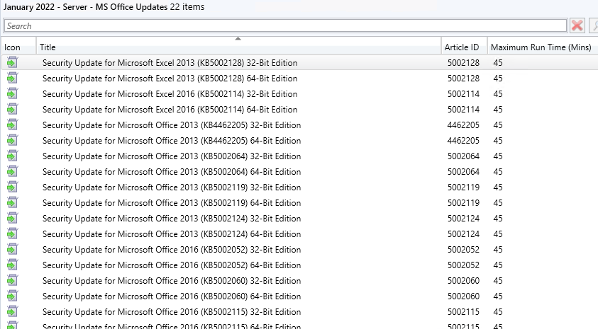

2.4. Enable Deployment



2.5. Review Released Software Updates and notifiy in email



2.6. SCCM Agent Remediation

Get list of servers from Release Portal those applicable for current month change and check SCCM agent installed and healthy on it

1. Monitoring Patch Deployment

[Overall Deployment Summary - SQL Server Reporting Services (corpnet1.com)](https://us1sxwnsql0116.wmservice.corpnet1.com/Reports/report/ConfigMgr_P01/_CustomReports/Test/Overall%20Deployment%20Summary)

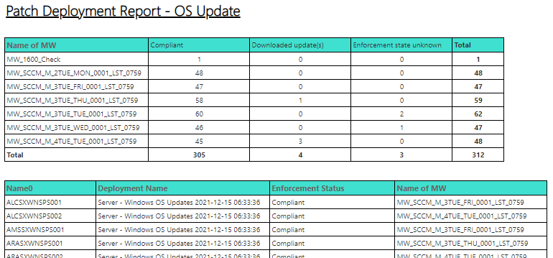

[Patch_OS_Update_Deployment_Status - SQL Server Reporting Services (corpnet1.com)](https://us1sxwnsql0116.wmservice.corpnet1.com/Reports/report/ConfigMgr_P01/_CustomReports/Test/Patch_OS_Update_Deployment_Status)

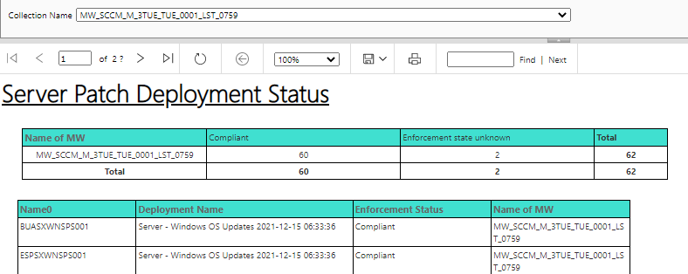

[Patch_OS_Update_Deployment_Status_custom - SQL Server Reporting Services (corpnet1.com)](https://us1sxwnsql0116.wmservice.corpnet1.com/Reports/report/ConfigMgr_P01/_CustomReports/Test/Patch_OS_Update_Deployment_Status_custom)

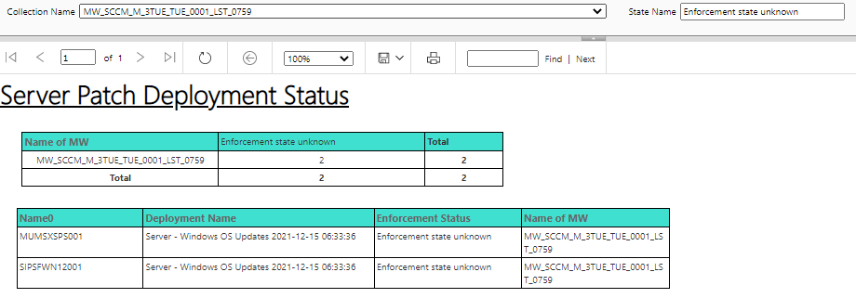

Weekly wise SCCM deployment status

[Test - SQL Server Reporting Services (corpnet1.com)](https://us1sxwnsql0116.wmservice.corpnet1.com/Reports/browse/ConfigMgr_P01/_CustomReports/Test)

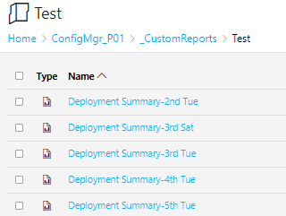

[Patching In Active Maintenance Window - SQL Server Reporting Services (corpnet1.com)](https://us1sxwnsql0116.wmservice.corpnet1.com/Reports/report/ConfigMgr_P01/_CustomReports/Patching%20In%20Active%20Maintenance%20Window)

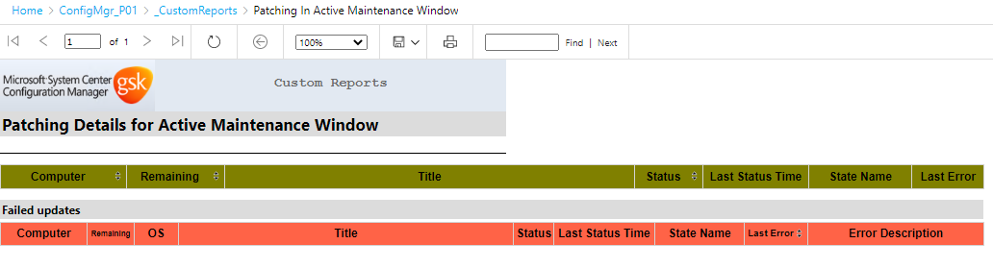

[Patching Details (Servers) - SQL Server Reporting Services (corpnet1.com)](https://us1sxwnsql0116.wmservice.corpnet1.com/Reports/report/ConfigMgr_P01/_CustomReports/Patching%20Details%20(Servers))

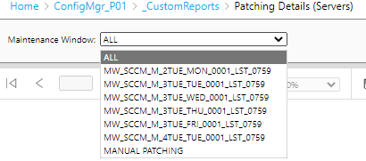

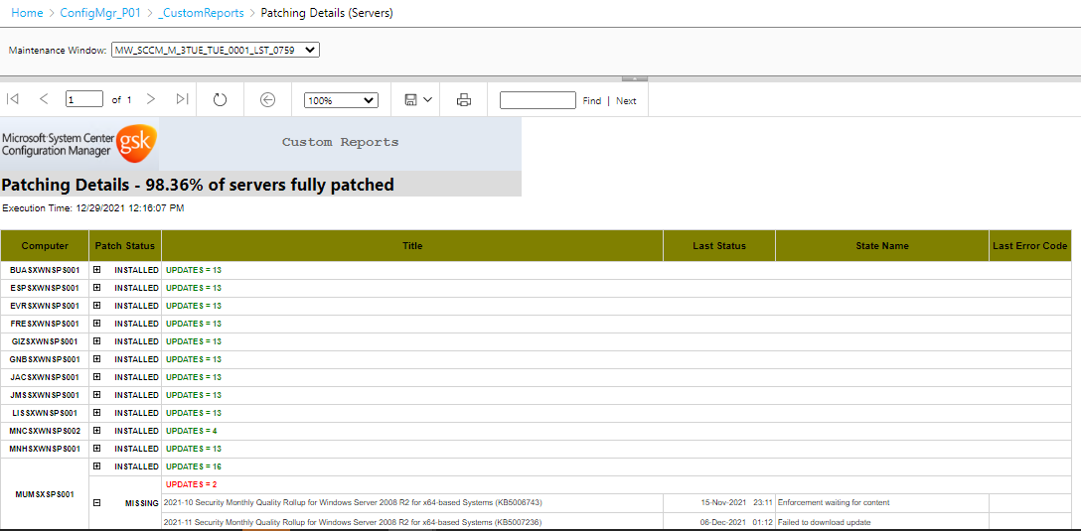

[Updates Status For Server - SQL Server Reporting Services (corpnet1.com)](https://us1sxwnsql0116.wmservice.corpnet1.com/Reports/report/ConfigMgr_P01/_CustomReports/Updates%20Status%20For%20Server)

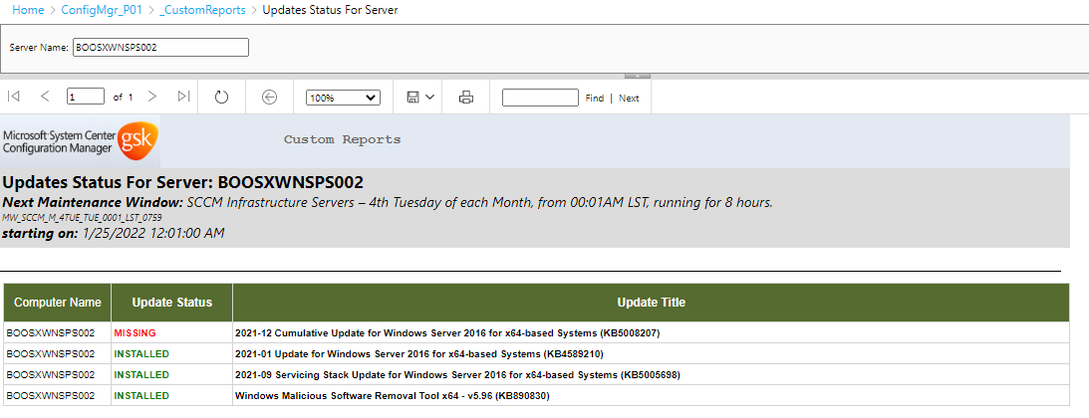

1. **Create Final Summary Report**

* Download the list of servers which are part of Active Maintenance windows from [Servers in active window history - Server release portal (gsk.com)](https://releaseportal.gsk.com/Manage/ComputersInActiveWindowHistory)

Go to Release Portal -> Reports -> Servers in active window history

Put Change number and select Scheduled from and to, you can get the list of servers which are part of Active Maintenance Window during selected period this report would help us to create the Final Summary Report.

* Download SCCM deployment summary report from SSRS report and SCCM agent installation report
* Prepare the Final Summary Report for 1st week , 2nd Week and Final Summary for Month as attached  



1. GSK Key Contacts & Roles

Windows Server Related -> IT_ITHS GHO Windows

Network Firewall Related -> PerimeterSecurityCompliance-L2

CyberArk Related -> HCL-CyberArk-PAMS

AD Related -> ADInfrastructure-L2

SCCM Related -> HCL GSK SCCM & ReleaseIntegration-L2

Server Release Related -> Server Release Team / Ray Grab; Krzysztof Karpinski; Neil Stewart

Release Portal Related -> Kevin Farrugia

1. RACI Matrix

